FRENCHMAN BAY PARTNERS ANNUAL MEETING

Saturday, May 13, 2017 9-12 pm

MDI Biological Laboratory

---------------------------------------------------------------------------------------------------

MINUTES

8:45-9:00 Coffee and catching up

9:00-9:20 Welcome and Introductions

18 people attended the 5th Frenchman Bay Partners Annual Meeting (Appendix 2). Anna introduced the meeting, then Jane took over for introductions.

9:20-9:35 Frenchman Bay Partner Committee Elections

The proposed slate was presented, Chris Petersen made a movement to approve the slate, it was seconded, and all in attendance agreed. The new Executive Committee for 2017-2019 is:
President: Jane Disney
Vice President: Natalie Springuel
Secretary: Anna Farrell
Member at Large: Larry Libby
Member at Large: Fiona de Koning

A question was raised about the difference between the Executive Committee and the Steering Committee. The Executive Committee responds to inquiries about the Partners, recruits new members, sets agendas and meetings, supports grants, and appoints committee chairs and members for any other committee that’s deemed necessary to support the Partners. The Steering Committee works with Partners and other stakeholders to facilitate and monitor the implementation of the Frenchman Bay Plan, and is part of the decision-making process to update the plan as necessary to reflect new ideas and information.

9:35-10:15 Conservation Target Updates (10 minutes each)
- Eelgrass: Jane Disney, MDI Biological Laboratory
Eelgrass has been declining in Frenchman Bay since it was first mapped by the Maine Department of Marine Resources (DMR) in 1996. Members of the eelgrass committee began restoring eelgrass beds in 2007, and methods for restoring have changed to fit the scale of the restoration over the years. In 2016, 2,175 vegetative plants were transplanted from Stave Island to Berry Cove.
Biodegradable grids are a proven method, but in 2015, the eelgrass group started experimenting with ceramic disks, collaborating with the New York State College of Ceramics at Alfred University. The disks can be prepared before the restoration day, can be deployed at any tide stage, degrade much faster than the grids, and show a 348% increase in eelgrass plants in a restoration plot vs. a 147% increase for grids. In 2016, three types of dissolvable disks were trialed.
In 2015 and 2016, the group determined carbon stock in sediment cores in areas where eelgrass is thriving and areas where there is eelgrass loss. There was not a significant difference between 2015 and 2016 at any site.
Next steps include continuing to work with collaborators throughout the New England area to understand eelgrass loss, continue mapping eelgrass and documenting carbon stock, dating sediment carbon to determine a carbon sequestration rate for Frenchman Bay, and continue to restore and protect eelgrass.
- Diadromous Fish: Chris Petersen, College of the Atlantic
The Diadromous Fish conservation target focuses on education, research, and restoration. The major goal of the committee is to restore fish runs on Jones Stream and Morancy Stream, which have a known history of alewives, and maintain the three other unobstructed runs on Frenchman Bay (Grist Mill and Card Mill Stream and Flanders Stream). The group continues to work with the property owner at Jones Stream, and has been working without the assistance of the DMR at Flanders and Morancy Streams. The fish ladder at Flanders Stream was recently rebuilt.
The group initiates formal and informal education programs. One formal program involves students in the Eastern Maine Skippers Program at MDI High School, who are conducting smelt surveys in various area streams. Committee members informally educate members of the public at public events such as the Birding Festival.
Most rivers in the area have three or more diadromous fish species. The group focuses on smelt and alewives. The DMR has an alewife research program, and volunteers/COA students help collect data for the DMR, counting, measuring, sexing, and taking scale samples from alewives. They are not seeing a lot of repeat spawners in the research. Every spring, volunteers monitor fish runs at the tidal dam in Somesville, Long Pond, and the Somes-Meynell Wildlife Sanctuary. In 2005, volunteers were counting around 350 fish/run. Now, numbers run upwards of 30-40 thousand fish. Downeast Salmon Federation and Acadia National Park are involved in the counts. In 2016, 60% of fish continued on to Long Pond instead of stopping in Somes Pond. Usually, only 40-50% of the fish make it to Long Pond. On Earth Day 2017, volunteers reestablished a fish way.
Eastern Maine Community College has a smelt monitoring project on Anecdata. Smelt tend not to go too far upstream. They are running strong in some areas, and weak in others.
The Union River dams in Ellsworth are currently up for a 30-year license renewal with the Federal Energy Regulatory Commission. Currently, alewives are trucked upstream to spawn, in a method called “trap and truck”, but other migrating species, such as American eels, are not included in this venture. Up until 2016, groups focused on facilitating upstream fish passage, but it has become clear that downstream passage is an issue as well. In October 2016, volunteers documented and collected herring and eels that had been killed or maimed while passing over the dam’s downstream fish passage or through its turbines (Downeast Salmon Federation).
- Mudflats: Fiona de Koning
Attention that was previously on water quality in Martin and Weir Coves has shifted to the Jordan River for two reasons: 1) Martin Cove and Mud Creek areas have been recommended to open by the DMR. 2) Water quality in the Jordan River is declining. The MDI Biological Laboratory is planning a watershed survey in summer 2017 to supplement DMR data and to narrow down pollution sources. In turn, the DMR has enacted an accelerated sampling program in the Jordan River Watershed.
Commercial harvesting license numbers are down. Recreational harvesting licenses are cheap; commercial licenses are not. Recreational harvesters are selling to commercial harvesters for profit.
There is an ongoing dialogue between a few groups regarding mussel management. There are lots of opinions on the multiple ways to utilize mussels; the Partners are trying to identify common goals between the dissenting groups. Students at College of the Atlantic are conducting seed mussel surveys in the Jordan River.
Recently, Acadia National Park banned harvesters from harvesting an area within Park boundaries. Legislation has been introduced into the House and Senate to revise boundary policies at Acadia and to resolve disputes between local harvesters and the National Park Service. For now, Acadia has agreed not to enforce the ban; basically, all is as it has been. Meetings on MDI and the Schoodic peninsula provide an opportunity for people to voice their perspectives on resource management.
Next steps include the watershed survey in the Jordan River, and asking regulators where they could use some help. The state knows they need to increase research on mussels; COA students are collecting data on mussel abundance and volume via censusing.
Someone asked why we aren’t focused on worm populations. They reported that the number of tape worms is “crazy”, especially at the Mt. Desert Narrows. This can have a negative effect on clam populations. Worm populations haven’t changed much since the 1970s, but the flats are getting lower, and wormers can’t work the same size tide anymore. The short answer to why the Partners aren’t addressing worms right now is that wormers come from all over the state, while clammers and mussel harvesters are local. The Partners are not only focused on resources in the bay, but also supporting local economies and bay users.
- Rockweed: Hannah Webber, Schoodic Institute
Rockweed harvesting is a $20 million industry in Maine. Currently, there is little to no commercial harvesting in Frenchman Bay. We’re trying to be proactive in understanding the resource in Frenchman Bay before harvesting becomes an issue, if it does.
In 2016, the FBP membership approved adding rockweed to the Frenchman Bay Plan as a conservation target. Following that, a rockweed working group was established. The rockweed group is currently developing goals around rockweed, having identified threats, drivers, and strategies for addressing threats. They are also collecting data on rockweed populations with citizen scientists and inventorying the rockweed resource in Frenchman Bay. The group’s major goal is bringing an objective, science-based lens to the possibility of controlled rockweed harvesting in Frenchman Bay and its impact on the bay.

10:15-10:30 Coffee and refreshments

10:30-10:50 Update from Emma Fox
Emma Fox, Ph.D. student at the University of Maine, discussed her thesis research on FBP ecosystem service valuation workshops, as well as her research on participatory Multi-Criteria Decision Analysis as part of the Future of Dams project.
For her master’s research, Emma did a case study on the FBP ecosystem valuation workshops. The Partners held several ESV meetings in Fall 2014. Though the ESV framework is gaining momentum in management scenarios, there are few studies on its actual application, particularly at the local level. At the end of the day, local use is what matters because that is where a lot of this work can be made actionable. Emma analyzed the workshops the Partners held, and a few themes emerged:
- Participants wanted more explicit organization and signage.
- Interpersonal connections and networking really added to the workshop.
- People wanted to be able to express more nuanced opinions.
- Participants thought the process was rather unclear, particularly the algorithm behind the scenes.
Emma then went through some recommendations she’d come up with based on her analysis before moving on to discuss her Ph.D. research on Multi-Criteria Decision Making. As part of this research, Emma will design her own tool for ranking decision alternatives. She takes into consideration decision alternatives, criteria, and preference weight when analyzing different decision alternatives.

10:50-12:00 Breakout Session: What does it mean to have a healthy intertidal?

The Park service is moving toward managing resources holistically and by balancing different needs and perspectives. Acadia National Park has over 60 linear miles of intertidal zone. Those miles have myriad pressures and the Park is looking to manage this resource in a way that recognizes those pressures. Not everyone sees the intertidal in the same way but everyone seems to agree that the Park needs a healthy intertidal, and that, for the Park, having a healthy intertidal underlies management strategies.

But what does that mean ‘healthy intertidal’? That, in and of itself, means different things to different people, for the Park and beyond. Here are a few examples: For a clam harvester it means a healthy, uncontaminated clam population, for a researcher it means untrammeled research sites, for a visitor it means safe exploration, and for a mother mink it means unimpeded access to food.

The FBP is a diverse group of people, with diverse perspectives on the Bay and possibly the intertidal that rings the Bay. For the breakout session, we asked this group to weigh in on the question of “What is healthy?” when it comes to the intertidal—whether that’s rocky, salt marsh, tidal flats or Sand Beach.

Each person self-assigned themselves to one of four categories: rocky intertidal, salt marsh, tidal flats, or Sand Beach. Collectively, each group defined what a healthy intertidal looks/smells/acts like, and what an unhealthy intertidal looks/smells/acts like (Appendix 1). Then, each group got a list of pre-defined items people think should be used to think about intertidal health. Collectively, groups ranked how important they thought the different metrics are for measuring the health of the intertidal. At the end, groups shared out their thoughts.

12:00 Meeting Conclusion

Appendix 1: Breakout Session
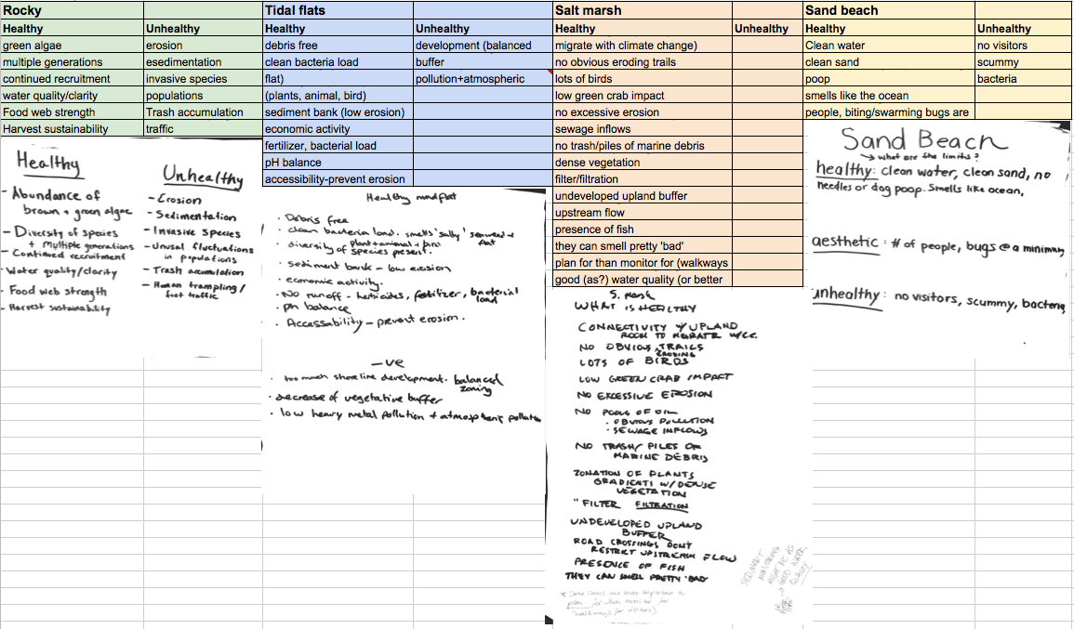
Breakout session answers to “What does it mean to have a healthy intertidal”?

Appendix 2: Attendees

First Name | Last Name | Affiliation
Jennifer | Fortier | City of Ellsworth
Chris | Petersen | College of the Atlantic
Jenn | Booher | Artist
Brian | Henkel | Friends of Acadia
Hannah | Webber | Schoodic Institute
Alan | Gray | Friends of Taunton Bay
Larry | Libby | Lamoine Conservation Commission
Anne | LaBossiere | Lamoine Conservation Commission
Anna | Farrell | MDI Biological Laboratory
Jane | Disney | MDI Biological Laboratory
Emma | Fox | University of Maine
Carol | Korty
Thomas | Atherton | Clam digger
Fiona | de Koning | Acadia AquaFarms
Bob | DeForrest | Maine Coast Heritage Trust
Aaron | Dority | Frenchman Bay Conservancy
Karlee | Markovich | MDI Biological Laboratory
Katie | Clark | College of the Atlantic

