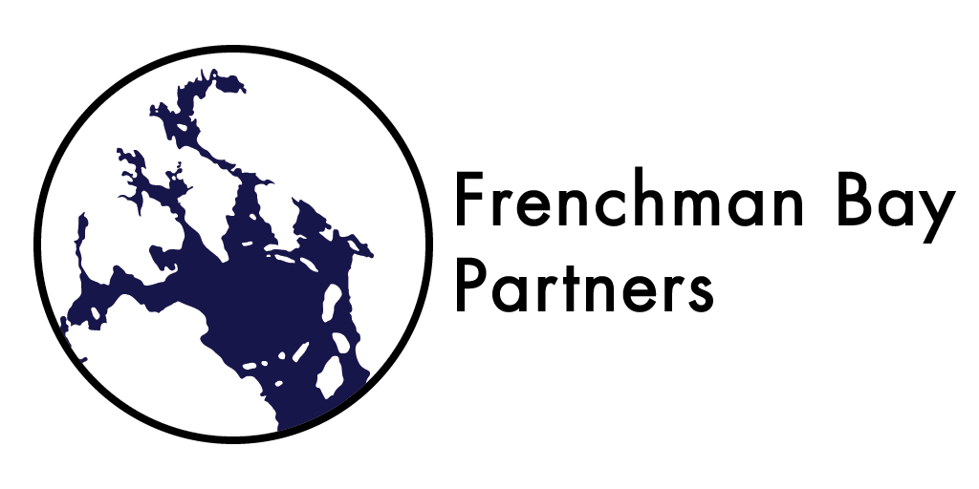

Frenchman Bay Partners Steering Committee Meeting
Location: Gordon's Wharf in Sullivan
Date and Time: Tuesday, September 29, 2015, 3-5 PM
Directions: http://friendsoftauntonbay.org/home/directions

Minutes

- Introduction of FBP Steering Committee Members, FBP Executive Committee, and guests

- Jane Disney, MDI Biological Laboratory, Executive Committee President
- Chris Petersen, College of the Atlantic, Executive Committee Vice President
- Bridie McGreavy, University of Maine, Executive Committee Secretary (call-in)
- Bob DeForrest, Maine Coast Heritage Trust, Executive Committee Member-at-Large
- Fiona de Koning, Acadia AquaFarms, Executive Committee Member-at-Large
- Robin Hadlock Seely, Shoals Marine Lab, Cornell University, Guest
- John Kelly, Acadia National Park Management Specialist, Steering Committee
- Hannah Webber, Schoodic Institute, Steering Committee
- Natalie Springuel, Maine Sea Grant, Steering Committee
- Roger Bowen, Gouldsboro Selectman, Steering Committee
- Larry Libby, Lamoine Conservation Commission, Steering Committee
- Carol Korty, Friends of Lamoine, Steering Committee
- Steve Weber, Board Member Frenchman Bay Conservancy
- Aaron Dority, Director Frenchman Bay Conservancy
- Antonio Blasi, Hancock Point Kayak Tours, Hancock County Commissioner, Steering Committee
- Anna Farrell, Maine Conservation Corps, MDI Biological Laboratory, Communications Committee

Jane oriented people to the agenda and gave a brief history of the Frenchman Bay Partners Steering Committee. The Steering Committee played a role during the development of the Frenchman Bay Partners and the Conservation Action Plan process five years ago. Once conservation targets were established, the Steering Committee was replaced by an Executive Committee and Subcommittees focused on the conservation targets. However, at the 2015 Annual Meeting, it was decided that the Frenchman Bay Partners would revisit the Steering Committee model as more people wanted more input.

- Discussion: Rockweed Harvesting in Frenchman Bay

Jane began by reiterating how the Partners arrived at the four conservation targets: by whittling a list of 10 down to four. Rockweed is not on that list. Jane and Chris added that, historically, the Frenchman Bay Partners have worked through issues by providing expertise and professional skills, not by taking legislative action. We've taken the route of stakeholder engagement and finding common ground through conflict resolution. However, more Partners are bringing up rockweed harvesting, a target that wasn't on the original list of ten. If we want to consider adding it to our conservation targets, we need to develop it fully, with goals associated with it. It could also be nested under a current target.

Robin Hadlock Seeley offered her expertise on rockweed, an area she has been studying for 20 years. The Partners discussed the following related to what she shared:

In 2014, the Rockweed Fishery Management Plan was passed by the Maine State legislature. The plan was developed by a committee called the Rockweed Plan Development Team, made up of three academics, three industry representatives, and two conservation representatives. Page 38 outlines specific research needs, such as the long term effects of rockweed harvesting, and cumulative effects on habitat. The final management plan did not have the "conservation piece", i.e., what areas will be considered "no harvest" areas. The plan was conditionally approved by the two conservation representatives, and a Rockweed Working Group was tasked with identifying "no harvest" areas. This process is still underway. The Maine Department of Inland Fisheries and Wildlife made a draft of "no harvest" areas, which included habitats of Priority 1 and Priority 2 sensitive species on the state action plan. Most of the species identified were birds, though a few marine mammals and seal pup haul-outs were included. The most recent draft report of recommended no harvest areas produced by the Rockweed Working Group can be found here (drafted July 2015).

The Gulf of Maine Research Field Network, a collaboration currently being developed, asked the state to make research stations off limits to rockweed harvesting. The state said okay, then changed its position because the Department of Marine Resources does not have the authority to make that decision. Conservation areas need to be identified through the legislature.

Within Cobscook Bay, Maine law prohibits commercial rockweed harvesting on all conservation properties (both preserves and easements). This stipulation does not extend beyond Cobscook Bay (http://www.downeastcoastalconservancy.org/rockweed/).

One of the major questions being asked is, "Is seaweed in the public trust?" If it is, rockweed harvesting would be managed by the Department of Marine Resources, similar to the way clams are managed. Conservation groups would not be able to protect the resource because it would be under state jurisdiction. If rockweed is not considered part of the public trust, then it would be managed privately, in a way that parallels the logging industry. The decision to make rockweed part of the public trust or not is complicated by unknowns, which is why scientific research is necessary. Another question on the table is whether or not rockweed harvesting is considered fishing. Regulations would differ depending on the answer.

Acadian Seaplants Limited is a Canadian rockweed harvesting company that plans to extend rockweed harvesting from Canada to the New Hampshire border. Dr. Raul Ugarte is a marine biologist at Acadian Seaplants Limited, and he was on the Rockweed Fishery Management Plan team. Acadian Seaplants Limited acts on the assumption that rockweed is currently in the public trust. The company has started harvesting rockweed in Cobscook Bay and employs rake harvesting rather than machine harvesting. Under current regulations, companies need to purchase buyer's licenses and harvester's licenses from the Department of Marine Resources to legally harvest rockweed. It is interesting to note that Acadian Seaplants Limited hires outside contractors to harvest rockweed (i.e. non-residents).

The Frenchman Bay Conservancy shared their approach to dealing with rockweed harvesting in Frenchman Bay. They've relied a lot on Robin's expertise, and created an ad hoc committee to form a position. The Board does not have a position on the issue at this time. There was a brief discussion on what the responsibilities of a land trust are regarding preservation of lands with rocky coastline that have rockweed beds..

After learning a bit more about rockweed and clarifying some questions, discussion centered around what role the Frenchman Bay Partners should play in decision making about rockweed harvesting. One partner suggested we need more background information on two things: the unknown impacts of harvesting, and how to translate the law around rockweed harvesting. Another partner suggested negotiating with harvesting companies to preserve Frenchman Bay. This is a method Downeast Coastal Conservancy has already attempted. It was clarified that "taking the issue of rockweed on" means setting realistic goals around rockweed, taking part in research, and writing grants and letters of support as necessary.

The Frenchman Bay Partners have always tried to address the ecological, economical, and cultural health of Frenchman Bay by focusing on our conservation targets.using a bottom up, rather than top down approach. This is reflected in our mission: to ensure that the Frenchman Bay area is ecologically, economically and socially healthy and resilient in the face of future challenges. A motion was made to continue the rockweed discussion to possibly create goals and strategies around rockweed habitat in the Frenchman Bay Conservation Action Plan.

Motion: The Frenchman Bay Partners move to devote a meeting to discussing rockweed harvesting and conservation as part of the Frenchman Bay Plan.

All present were in favor of passing the motion.

- Discussion of Steering Committee role in Frenchman Bay Partners

One role of the steering committee is making sure others who need to be at the table are at the table.

- Committee Update: Diadromous Fishes
- Southern Maine had a horrible alewife run this year.
- Downeast Maine had a pretty good run this year.
- The run at Flanders Stream ran from Mid-May to Late June.
- Claire Enterline, DMR, and Chris Petersen gave a talk about the run this year at Somes-Meynell in September.
- Claire Enterline has left the DMR.
- A run has not yet established itself at Morancy Stream.
- There are interesting ideas being considered for Jones Stream in Gouldsboro.

- Committee Update: Eelgrass
- Eelgrass came up this year right on top of previous restoration areas.
- A new prototype, ceramic weights, was trialed this summer. The Department of Ceramic Engineering at Alfred University developed the weights, and is currently working on a dissolvable disk prototype.
- The Community Environmental Health Lab repeated a week-long green crab trapping study to compare green crab numbers in Frenchman Bay in 2014 and 2015; the two years had comparable numbers of green crabs
- One summer intern at the Community Environmental Health Laboratory researched carbon stock in eelgrass beds and found significant differences between areas. There was more carbon stored in sediments in beds with healthy eelgrass than in areas with declining eelgrass.

- Committee Update: Mudflats
- 610 Project :
  - Approximately 70 acres opened in Kilkenny Cove, which had been closed since 1987. This was accomplished by a collaboration between the Department of Marine Resources, the Department of Environmental Protection, and the Frenchman Bay Regional Shellfish Committee, a relationship facilitated by the Frenchman Bay Partners.
  - The Mill Brook area in Taunton Bay has reopened due to the removal of a known pollution source.
  - A digging area in Lamoine was closed in May due to water quality levels just above the threshold. This is an easily accessible site. Dog waste may be the source of contamination. Dog waste bags have since been replaced at the site.
  - Both Meggan Dwyer and Allie Rohr have left the DMR. Both played important roles in the Partners' relationship with the DMR.
  - Funding is still available for working on Martin and Weir Coves.
  - Bridie is working with the Maine Migrant Health Program to help harvesters get access to health services.
- pH
  - College of the Atlantic began shell addition experiments on clam flats in May 2015. There are several 2 x 2 m plots at Hadley Point East, which are being used to look at pH, recruitment, and adult density, among other factors. Chris applied for and received a permit from the ArmyCorps and DEP for these plots in July.
- The area west of the Trenton Airport seaplane ramp has been closed due to fecal contamination. The site is a state priority; Allie Rohr was working hard to solve the problem. The DMR has proven to be a good collaborator on the issue.

- Committee Update: Benthic Habitats
- There is nothing new to report regarding Benthic Habitats.
- We still do not have a head for this committee.

- Committee Update: Communications
- The Fall newsletter is in the works right now. If anyone would like to contribute stories, research, successes, events, etc., the deadline is October 15. Send any submissions to afarrell@mdibl.org.
- It was decided that establishing a Frenchman Bay Partners Instagram account would be a good addition to our social media suite, particularly in attracting the younger crowd.

- Next Steps
- Quarterly Steering Committee Meeting
- May Annual Meeting
- Rockweed Discussion Meeting in January

